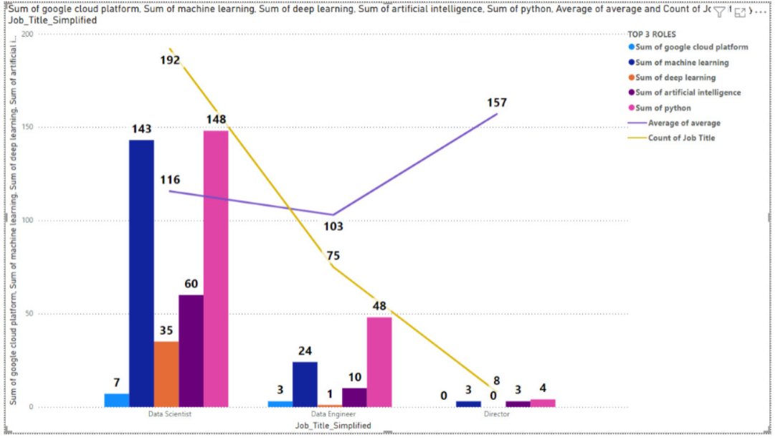

* Top 3 job roles analysis with their jobs count in different sectors and locations, average salary and the distribution of python, ML, AI, Deep learning distribution among them:

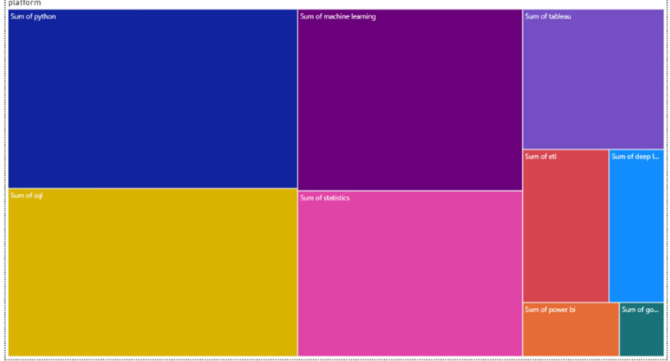

* This report shows the important skills rank in our data and their which says many jobs require python.

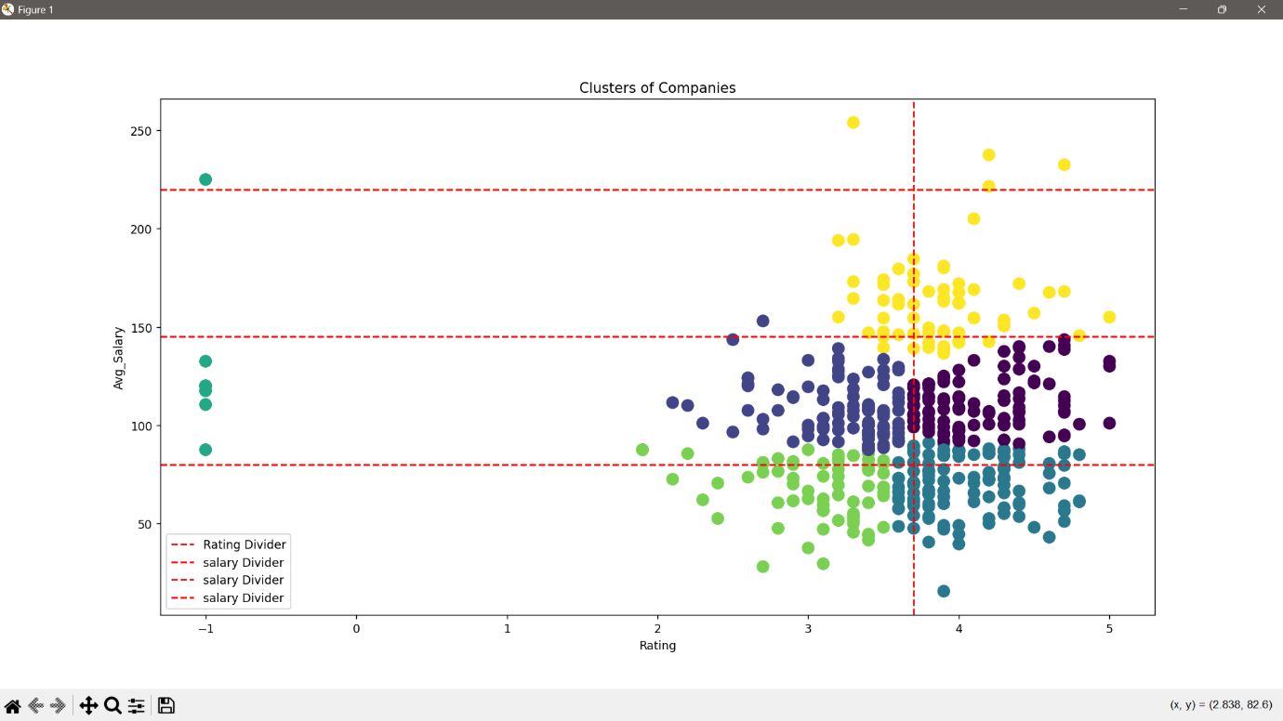

It shows the relationship between company ratings (x-axis) and average salaries (y-axis). The data points are color-coded to represent different clusters identified by the K-Means algorithm.

Insight:

Company’s Rating doesn’t affect salary both are independent.

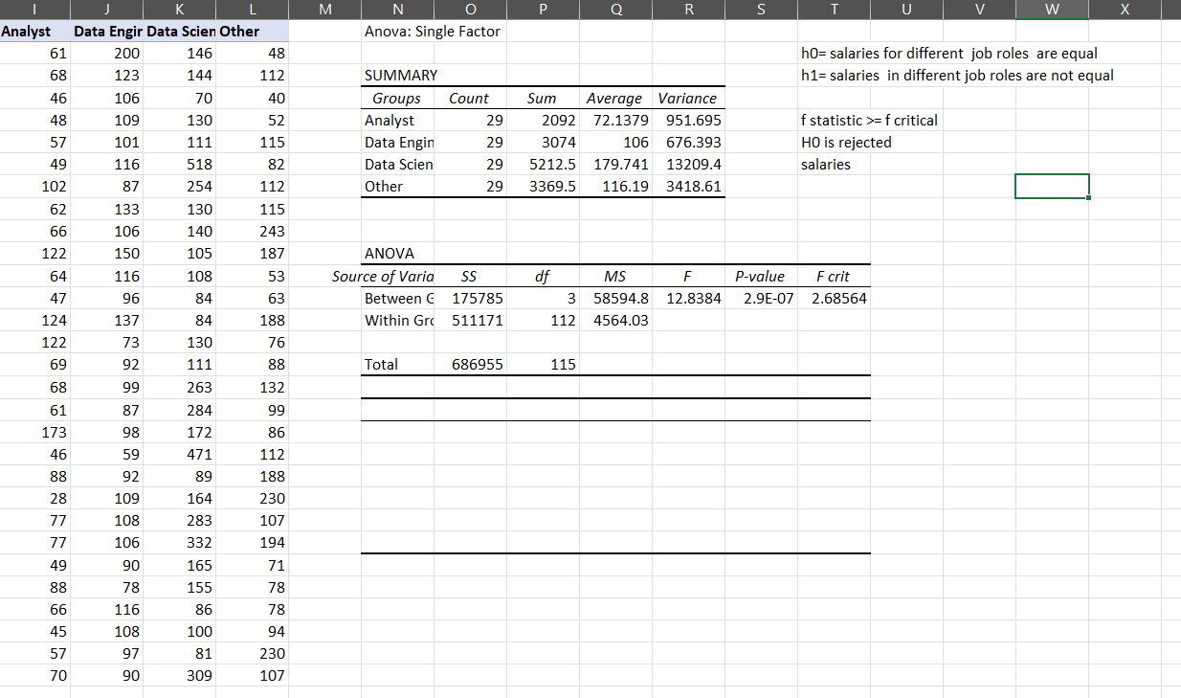one way Anova test on job roles and average salaries